* Let’s cover sets; they are also a type of collection.
* Sets are a type of collection. This means that like lists and tuples, you
* can input different python types. Unlike lists and tuples they are unordered.
* This means sets do not record element position. Sets only have unique elements.
* This means there is only one of a particular element in a set.
* To define a set, you use curly brackets You place the elements of a set within the
* curly brackets. You notice there are duplicate items.
* When the actual set is created, duplicate items will not be present.
* You can convert a list to a set by using the function set; this is called type-casting.
* You simply use the list as the input to the function set.
* The result will be a list converted to a set. Let's go over an example
* We start off with a list. We input the list to the function set.
* The function set returns a set. Notice how there are no duplicate elements.
* Let’s go over Set Operations; these can be used to change the set.
* Consider the set “A”. Let's represent this set with a circle.
* If you are familiar with sets this can be part of a Venn diagram.
* A Venn diagram is a tool that uses shapes usually to represent sets.
* We can add an item to a set using the add method.
* **We just put the set name followed by a dot, then the add method.**
* The argument is the new element of the set we would like to add, in this case, "NSYNC".
* The set "A" now has "NSYNC” as an item. If we add the same item twice, nothing will
* happen as there can be no duplicates in a set.
* Let’s say we would like to remove NSYNC from set A.
* We can also remove an item from a set using the remove method.
* We just put the set name followed by a dot then the remove method.
* The argument is the element of the set we would like to remove, in this case, "NSYNC".
* After the remove method is applied to the set, set "A" does not contain the item
* "NSYNC”. You can use this method for any item in the set.
* We can verify if an element is in the set
* using the "in" command as follows. The command checks if the item, in this case,
* "AC/DC" is in the set. If the item is in the set, it returns true.
* If we look for an item that is not in the set, in this case for the item “Who”,
* as the item is not in the set, we will get a false.
* These are types of mathematical set operations; there are other operations we can do.
* There are lots of useful mathematical operations we can do between sets.
* Let's define the set "album_set_1", we can represent it using a red circle or Venn diagram.
* Similarly, we can define the set "album_set_2”.
* We can also represent it using a blue circle or Venn diagram.
* The Intersection of two sets is a new set containing elements which are in both of those
* sets. It's helpful to use Venn diagrams.
* The two circles that represent the sets combine; the overlap represents the new set.
* As the overlap is comprised of the red circle and blue circle, we define the intersection
* in terms of “and.” In Python, we use the ampersand to find the
* union of two sets. If we overlay the values of the set over the
* circle placing the common elements in the overlapping area, we see the correspondence.
* After applying the Intersection operation, all the items that are not in both sets disappear.
* In Python, we simply just place the ampersand between the two sets.
* We see that both "AC/DC" and "Back in Black" are in both sets.
* The result is a new set album, set 3, containing all the elements in both album_set_1 and album
* set 2.
* The union of two sets is the new set of elements
* which contain all the items in both sets. We can find the union of the sets album set
* 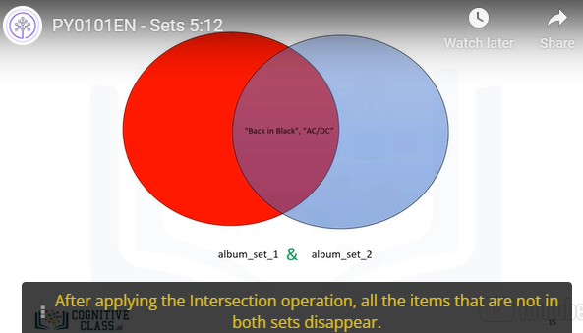1 and album_set_2 as follows. The result is a new set that has all the elements
* of album_set_1 and album_set_2. This new set is represented in green.
* Consider the new album set, "album_set_3"; the set contains the elements "AC/DC" and "Back
* in Black”. We can represent this with a Venn diagram,
* as all the elements in album_set_3 are in album_set_1.
* The circle representing album_set_1 encapsulates the circle representing album_set_3.
* 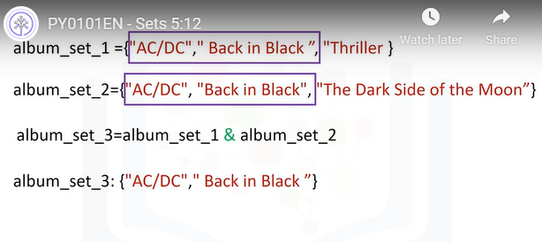
* We can check if a set is a subset using the is subset method.
* As album_set_3 is a subset of the album_set_1, the result is true.
* There is a lot more you can do with sets. Check out the lab for more examples.

